Workshop
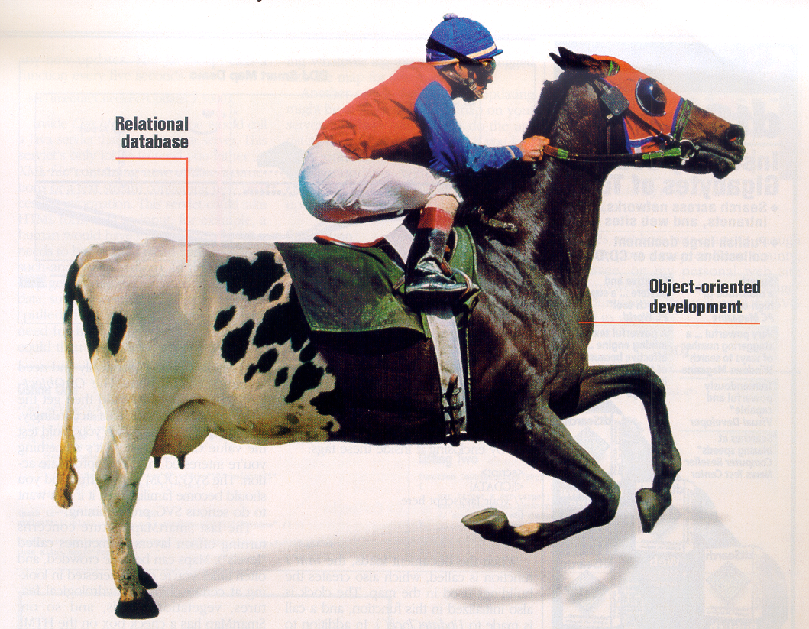

Persistence

Workshop 1
Persistence 1
Objective: 2
Intended Learning Outcome 2
Working Methods 2
About the workshop 3
Student material 3
Literature 3
Demands for documentations 3
Evaluation 4
Assignments 4
Western Style Ltd. 5
Economic review/summary 7

Objective:

To get knowledge about activities in connection with creation and maintenance of databases and to get experience with accessing databases from Java programs.

Intended Learning Outcome
- Analyze and model a problem domain for use in a database-backed system
- Design a database model from the domain model using transformation rules
- Being able to design a database which satisfies the requirements for good design (Normalization)
- Produce SQL-scripts that create and populate the database
- Design, document, and build a software system using a three-layered open architecture and the DAO pattern for data access
- Improve team work skills

Working Methods

Assignments are to be solved in groups, which themselves decide the distribution of work and assignments between team members.
The in-depth learning is achieved by working with the assignments of the workshop. To ensure the highest possible quality of the solutions it is important that you work at the UCN where problems can be discussed with team members and supervisors.
If you experience problems in the team working process, contact a supervisor for a meeting before problems get out of hand.

The database has to be located on kraka.ucn.dk. You must use SVN for version control.

About the workshop
The plan for the workshop is the following:

Day 1 Introduction to the assignment, workshop starts, start producing products
for day 2.
Day 2 Milestone (system development review):
Working papers about mock-ups, domain models, interaction diagams, test cases, relational models together with SQL-scripts for creation of the database are to be reviewed.
Day 3 Working with the assignments.
Day 4 Working with the assignments.
Day 5 Working with the assignments.
Hand in by uploading to Wiseflow. Check Wiseflow for the exact hand-in time.
Each student has to upload. One file with:
- Required documentation
- Repository path
- Revision number
And the code in a zip file.

The system development and programming teachers will be available most days; see your schedule for details.

Student material
The following material will be available on the intranet:
Lecture note: Persistence, An Example Architecture for Encapsulation of Database Access in Java Systems
A basic example in how to use JDBC is available from previous sessions
Slides from the previous sessions

Literature
Elmasri.

Required documentation
- Mock-ups
- Fully dressed use-case description for order processing and relevant documentation for that use-case.
- Domain model with comments
- Interaction diagrams for the fully dressed use-case and selected test cases
- Transformation of the domain model to a relational model with comments
- SQL scripts for the creation of the database.
- SQL scripts for the insertion of data into the database.
- Code standard
- The test classes must be a part of the Eclipse project.
- Your final program as an Eclipse project.
- Your database located on kraka.ucn.dk

The documentation must be in one document (word or pdf).

Evaluation

The teams demonstrate and review/discuss the developed database program (approximately 40 min. each team >=3 persons OR approximately 30 min. each team < 3 persons). Available time is divided up into a presentation by the team, questions from the teachers, and feedback from the teachers.

Group 1 8.30 – 9.10
Group 2 9.10 – 9:50
Group 3 9.50 – 10.30
Group 4 10.30 – 11.10
Group 5 11.10 - 11.50

Assignments
From the case “Western Style Ltd.” your assignment is to create part of a computer system. This work will give you the possibility to build a system in Java using a relational database.
The domain model is not complete/correct, so if you should discover some errors/mistakes it is your job to make the necessary adjustments (in the model). In the first version of the system, you may want not to implement the specialisation hierarchy modelling different products.
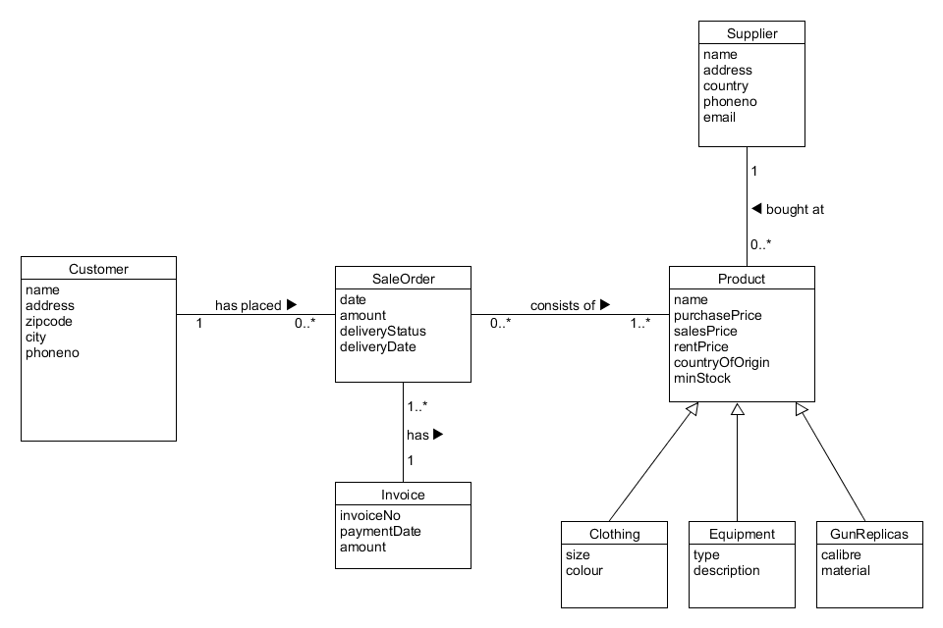
- Based on the domain model a relational model is to be designed (mapping/transformation).
- Script(s) for creation of the database and insertion of data are to be written.
- Java programs are to be created so it is possible to carry out CRUD operations on the Customer and Product classes.
- Finally the use case for order processing is to be described, designed, and implemented. Besides that you must write test classes.

Western Style Ltd.

Western Style was established in 1994 by Hanne and Børge Pedersen. The company consists of one store which is located in Viborg and furthermore the company attends festivals, markets and concerts where they promote their range of products. The concept of the company arose when Hanne and Børge attended square dance lessons and found it difficult finding stylish cowboy clothing for the dancers. First they started importing clothing only but later on also many other western related items. In the year 2012 the company was turned from a startup (sole proprietorship) into a private limited company (Ltd) with a stock capital of DKK 500.000,-

In the beginning it was especially the US/American market, who was the main supplier, but the company has expanded substantially, including the field/area of suppliers, and today many items come from Hungary and Poland and Børge still visits trade fairs to find new relevant and competitive suppliers. Børge and Hanne are responsible for purchasing new products to the assortment, while inventory control and keeping supplies in stock is done by other employees in teamwork.

During the years the company has grown from being a spare time business to becoming a company with 6 employees in addition to the owners. Kent Andersen is the accountant and furthermore manages debtor and credit control. Nina Munkholm is responsible for running the store on a daily basis and makes the work plans, holiday planning and coordinates who participate in some of the arrangements in the outside world. So far sales have been limited to the Danish market and foreign tourists visiting Denmark, but the objective is to expand somewhere in the future.

The additional 4 employees manage service and sale/sales promotion along with packing and dispatching of merchandise all over the country. Today, many orders are made from societies, who place their orders from the catalogue the company put out 2 times a year. Furthermore advertising is done in dailies, magazines and trade journals.

Closer analysis and categorization of the costumers have not been done but most are square-dancer clubs, line-dancer clubs, western clubs, riding clubs with western riding disciplines and private persons. Clubs that purchase for more than DKK 1.500,- receive a discount, while private persons who buy for more than DKK 2.500,- get their delivery free of charge. If the customer didn’t reach the free of charge limit, they’ll have to pay an additional DKK 45 for freight. Orders are usually placed by phone or mail order. After that the order is delivered from stock and an invoice and a delivery note is printed to go with the purchase.

Stock control is done by count/manually and furthermore there is a transportable remote warehouse where it is possible to store. Control is done by stock count and besides there is a transportable remote warehouse, given that the company has a van used for markets and festivals and sometimes this warehouse needs refilling. A computer system for updating the warehouse directly is desired, in that way it would be possible to control what needs filling up.
Western Style have received several inquiries from potential business associates who wish to establish similar companies/shops other places in Denmark and in other Nordic countries. As a result a potential expansion, of other shops or some sort of franchising, is presently taken into consideration.

Presently the product range consists of

Cowboy hats
Cowboy boots
Cowboy clothing
Denims
T-shirts
Shirts
Ponchos
Vests
Leather Jackets
Dresses
Skirts
Oilskin Jackets
Chaps
Overalls
Ties
Earrings
Necklaces
Belts and buckles
Pistol Belts
Gun Replicas
Sheriff uniforms and equipment
Jewellery
Scarves
Gifts, Candlelight’s, Ornaments,
Gift Boxes, Key Rings
Decorations
Flags
Personalized Licence Plates
Zippo Lighters
Money Clips
Bags
Western and Country music CDs

From these there is a selection of items which can be rented in connection with completion of cultural events.

IT-systems

The company’s IT-equipment has been updated continuously and presently consists of a network with a server, 2 PCs which are placed as point of sale terminals (POS) in the store/shop and 1 PC which is used for the daily accounting and payroll administration along with budgeting done in spreadsheet (used by the accountant, Børge and Hanne). Moreover there is a PC for making general calculations, discount calculations and inventory control (used by Nina, Børge and Hanne). One of the shop assistants has an education as IT-administrator and attends to super user assignments. Among others he takes back-ups of all transactions each Friday. The programs used are MS Office, MS Windows.

Economic review/summary
Accounting figures from the past 3 years.

Profit and loss account

(DKK 1000,-)
 |  | 2014 | 2015 | 2016
Turnover |  | 5500 | 6102 | 6843
Cost of sales |  | 2508 | 2885 | 3401
Gross Profit |  | 2992 | 3217 | 3442
Variable costs |  | 100 | 105 | 145
Contribution (profit) |  | 2892 | 3112 | 3297
Capacity/overhead costs
Promotional Costs |  | 324 | 380 | 402
Rental of premises costs |  | 125 | 148 | 168
Salaries |  | 1509 | 1602 | 1725
Other costs |  | 111 | 145 | 162
Cash capacity costs in total |  | 2069 | 2275 | 2457
Contribution of earnings |  | 823 | 837 | 840
Depreciations |  | 200 | 202 | 192
Financial result |  | 623 | 635 | 648
Interest rate costs |  | 25 | 26 | 23
Pre-tax profit |  | 598 | 609 | 625
Company tax |  | 179 | 183 | 188
Net profit |  | 419 | 426 | 438

Balance (sheet)
Balance (sheet) | 2013 | 2014 | 2015 | 2016
Assets
Fixed assets | 1200 | 1210 | 1190 | 1150
Inventory | 556 | 580 | 595 | 687
Trade debtor | 150 | 145 | 135 | 154
Accruals basic accounting | 2 | 4 | 10 | 5
Cash balance | 200 | 251 | 300 | 450
Assets in total | 2108 | 2190 | 2230 | 2446
Liabilities
Share capital | 500 | 500 | 500 | 500
Reserves | 600 | 652 | 693 | 780
Property Loan | 250 | 235 | 215 | 200
Overdraft/bank line (max.500) | 150 | 145 | 152 | 189
VAT liabilities | 85 | 92 | 105 | 110
Trade creditors | 256 | 289 | 305 | 358
Other creditors | 50 | 53 | 65 | 74
Company tax (outst.amounts) | 167 | 174 | 145 | 185
Dividend outstanding amounts | 50 | 50 | 50 | 50
Liabilities in total | 2108 | 2190 | 2230 | 2446

